# STEPS FOR TASK 2

1. CONNECT TO THE DATABASE
2. CREATE DATABASE NAMED DWH ASSIGNMENT
3. CREATE TABLE dbo.Group_member
4. dbo.Group_member contain id,firstname,lastname,address,phone_number
5. Configure two connection managers for csv files and Sql server
6. Define data flow for this task to integrate csv’s with Sql server with the help of join

## SQL SCRIPT FOR TASK 2

use [DWH assignment ];

create table dbo.Group_member(

id int,

Firstname varchar(50),

Lastname varchar(50),

Address varchar(50),

Phone_Number varchar(11)

);

select * from dbo.Group_member;

## DATABASE TABLE COLUMNS FOR TASK 2

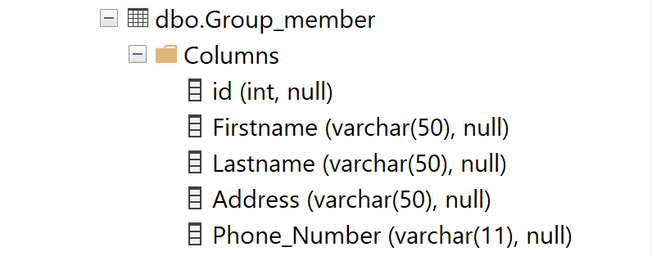

### CSV FILES FOR TASK 2

 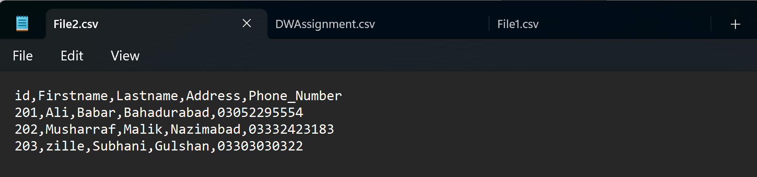

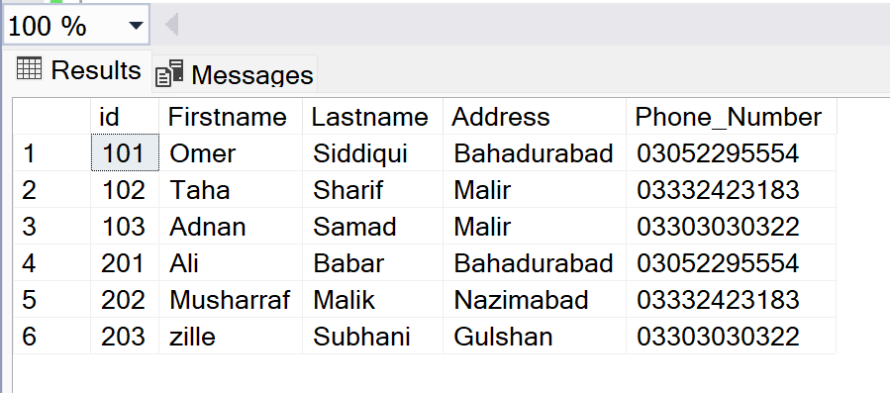

### INTEGRATION TASK 2

